**Lab 5 Deliverables**

Akaash Chikarmane and Milan Feliciello

Section: 16085

Spring 2016

**Logic Analyzer – cars on both roads**

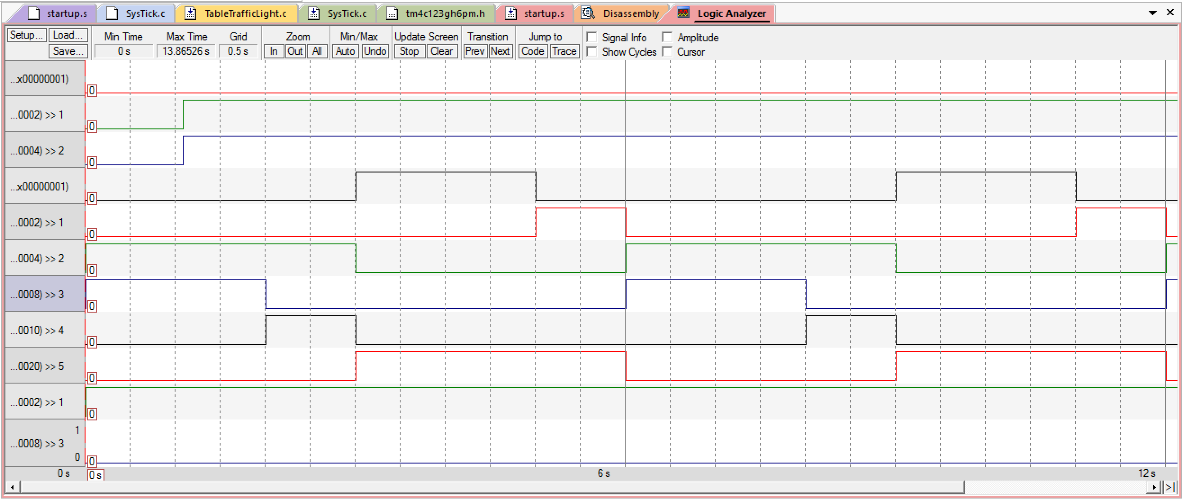

**Circuit Diagram**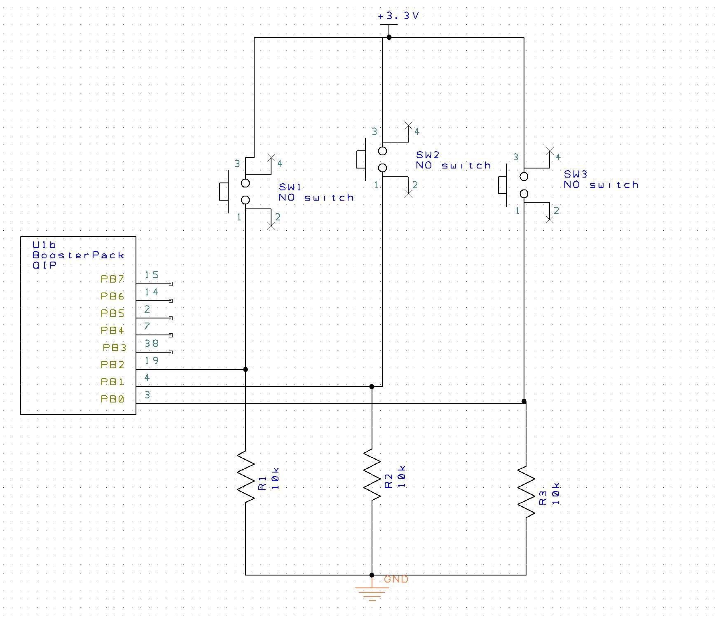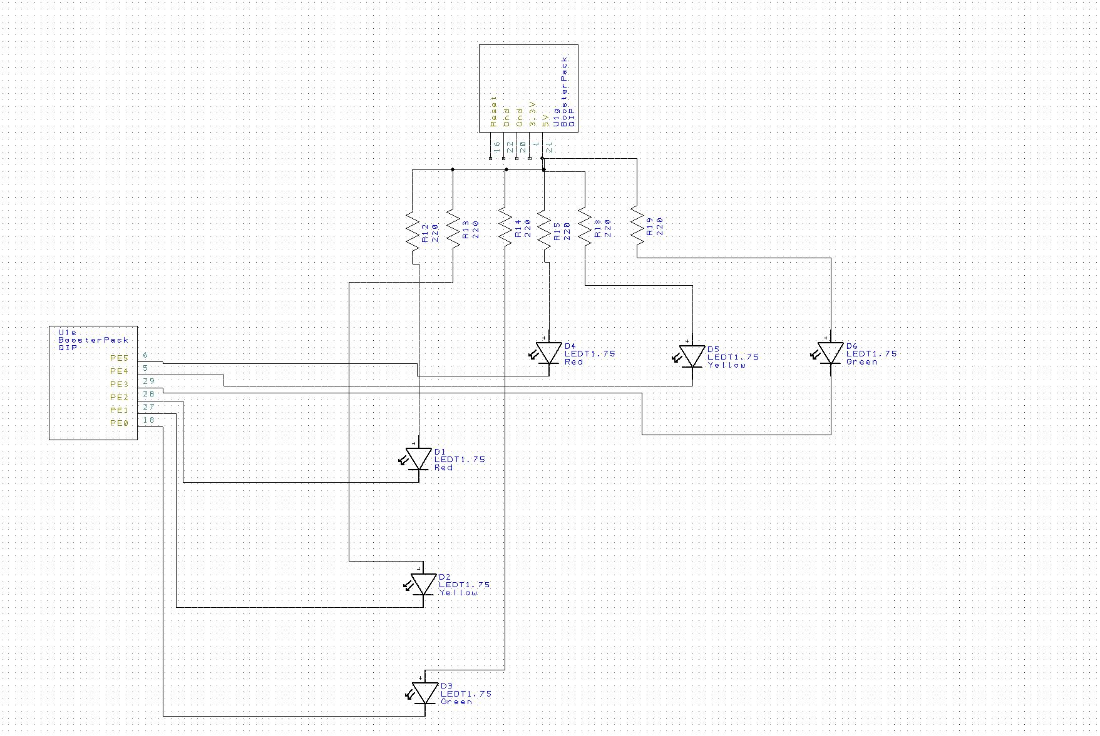

**Finite State Machine**

